Lecture 12 - Google Earth Engine

**Principal Component Analysis**

<https://github.com/johntango/Financial-Machine-Learning-Articles>

<https://www.yaoleixu.com/a>

Video on PCA <https://www.youtube.com/watch?v=FgakZw6K1QQ>

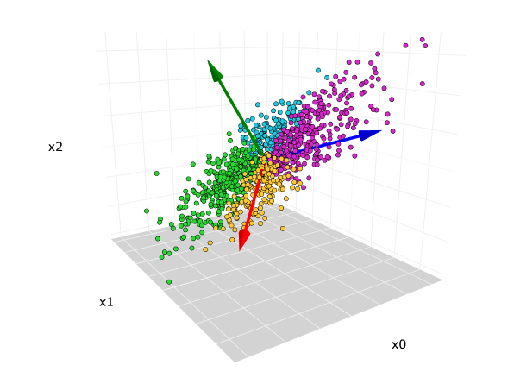

|  | M 1 | M 2 | M 3 | M 4 | M5 | M 6 |
| --- | --- | --- | --- | --- | --- | --- |
| Gene1 | 10 | 11 | 8 | 3 | 3 | 1 |
| Gene 2 | 6 | 4 | 5 | 3 | 2.8 | 1 |
| Gene 3 | 12 | 9 | 10 | 2.5 | 1.3 | 2 |

Brilliant Video of Gil Strang on Singular Value Decomposition (SVD and PCA) <https://www.youtube.com/watch?v=rYz83XPxiZo>

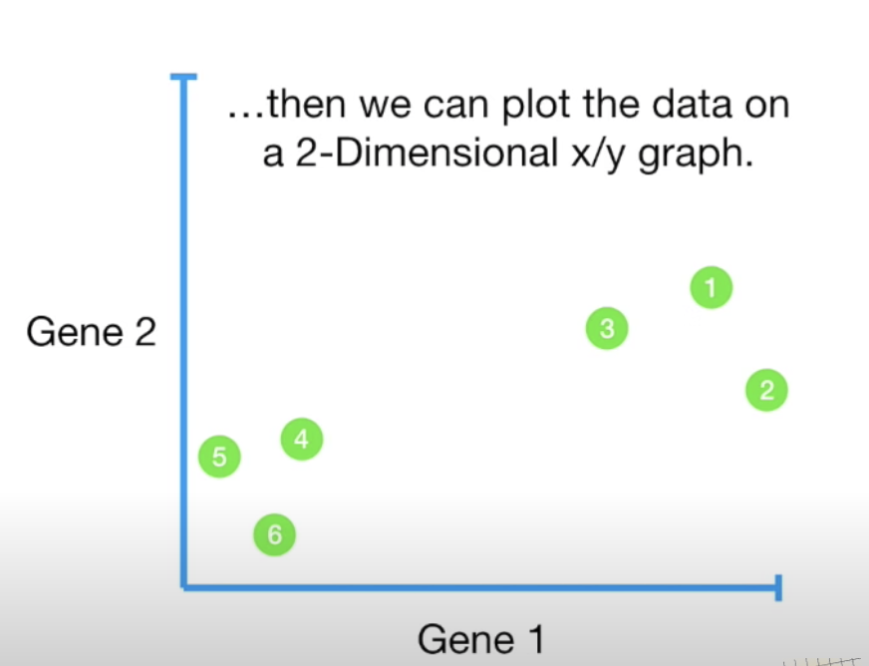

Below is PCA for a time series

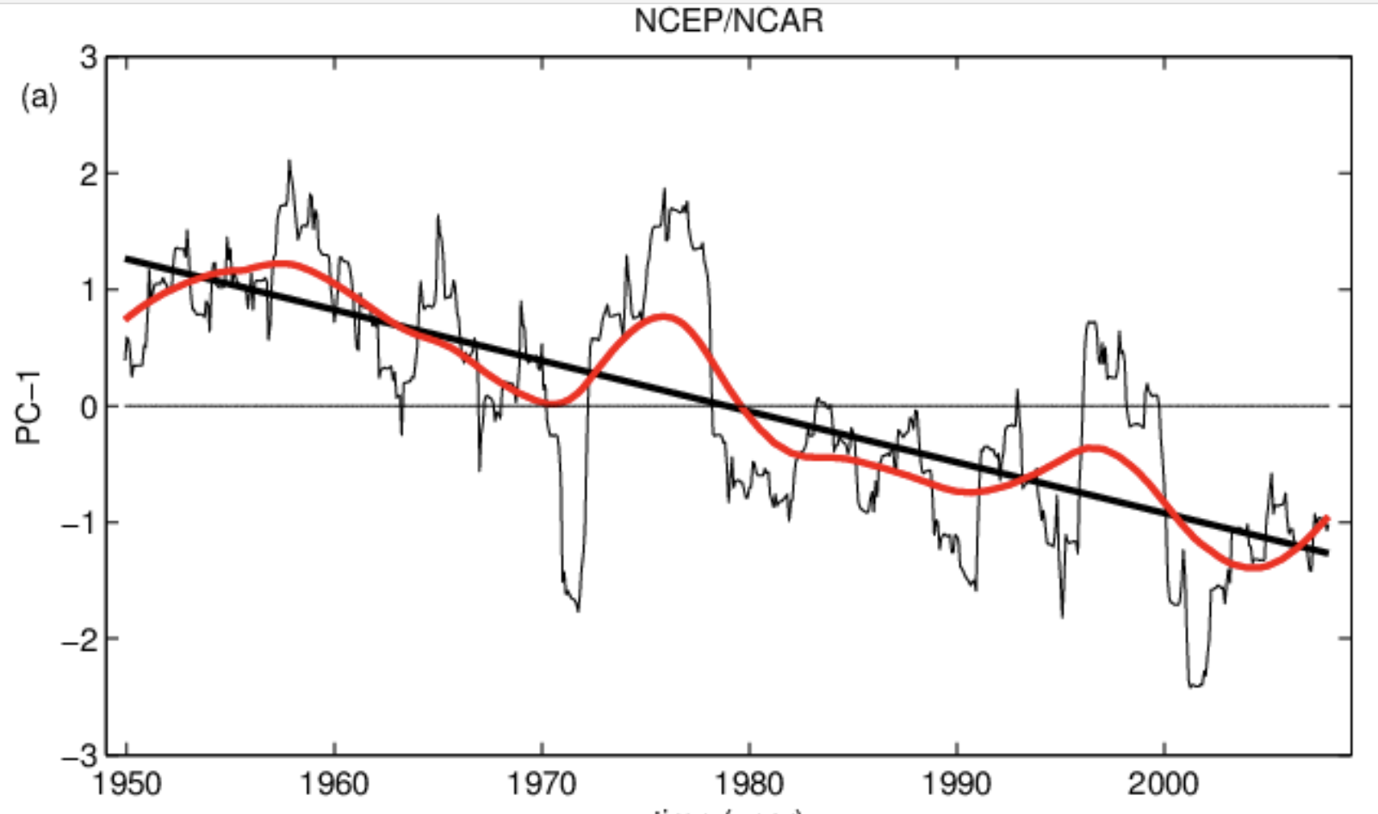

**Google Earth Engine**

Follow along here

<https://developers.google.com/earth-engine/guides/image_overview>

Slides <https://docs.google.com/presentation/d/1iZtkBNzl2HBWFT0wEhwCov89kyiBO7rSHcmMa6WNMa8/edit#slide=id.g2274af231f_0_36>

Exercise in class. London at Night

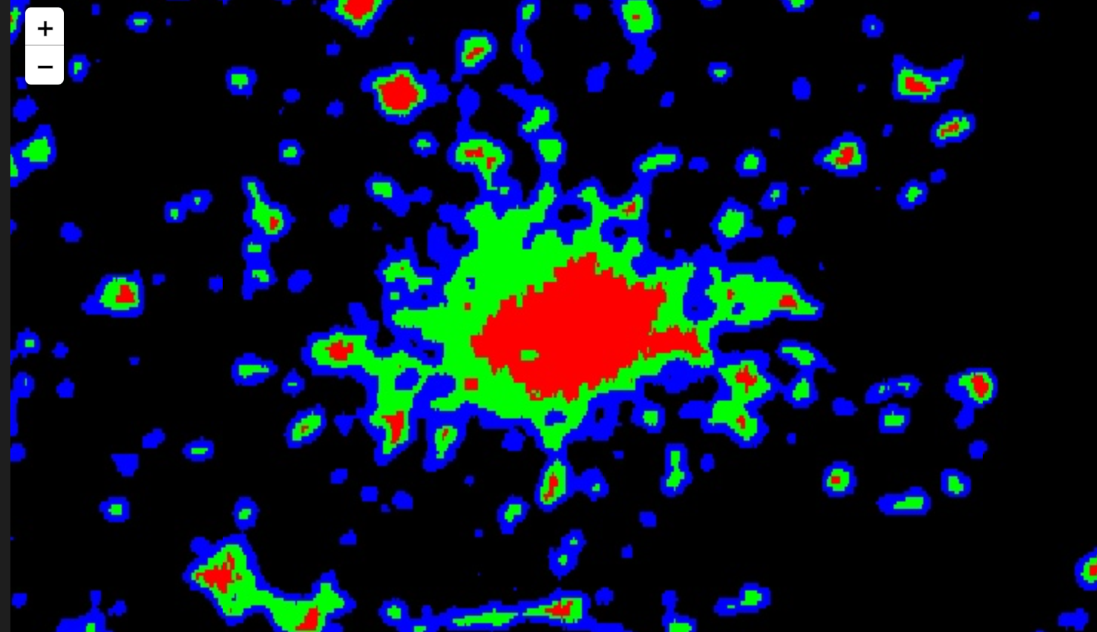

Good Video on Use of Vegetation Index to generate Crop Yields

Addresses turning pixel values into meaningful data (problem of mixed pixels)

Addresses improving pixel values by overlapping multiple images

[Meha Jain - A Scalable Satellite-based Crop Yield Mapper](https://www.youtube.com/watch?v=5HeJDKF8XCw)

Lecture 11 - Google Earth Engine

Repo for today

<https://github.com/johntango/GoogleEarthEngine>

You can use Google Earth Engine in Colab or Python on your own machine.

To install the Python version on your laptop

### Repo <https://developers.google.com/earth-engine/guides/python_install>

We will work through the tutorial on Colab

<https://developers.google.com/earth-engine/tutorials/community/intro-to-python-api>

The same tutorial on Colab

<https://colab.research.google.com/github/google/earthengine-community/blob/master/tutorials/intro-to-python-api/index.ipynb#scrollTo=gzHi1xooUJ1A>

Here are two ways of selecting a region of the earth:

1. Global Administrative Unit Layers (GAUL)
2. Region Lat Lon

Here is a video showing how to export an image from Google Earth to Google Drive

<https://www.youtube.com/watch?v=gMT_yr1_Yag>

Using this

In Class

Name Email Region Lat Lon Link

| John Williams | jrw@mit.edu | Boston | u_lon = -71.057083  u_lat = 42.361145  r_lon = -71.8023  r_lat = 42.2626 |
| --- | --- | --- | --- |
| Alice Zehner | azehner@mit.edu |  |  |
| Ellie Vaserman | ellieav@mit.edu |  |  |
| Francisco | fcosep@mit.edu |  |  |
| Ava Dijstelbloem | avad114@mit.edu |  |  |
| Richard Chen | rachen@mit.edu |  |  |
| Rina Cao | rinacao@mit.edu |  |  |
| Yuru Zhang | yuru@mit.edu |  |  |
| Laura Chen | Lcchen3@mit.edu |  |  |
| Muna Nwana | mnwana@mit.edu |  |  |
| Ella Gersack | egersack@mit.edu |  |  |
| Ariel Attias | aattias@mit.edu |  |  |
| Storm Mata | storm22@mit.edu |  |  |
| Neil Hallock | nhallock@mit.edu |  |  |
| James Shaw | jshaw4@mit.edu |  |  |
| Jahanara Rahemtulla | jrahem@mit.edu |  |  |
| Naylah Canty | naylahc@mit.edu |  |  |
|  |  |  |  |
|  |  |  |  |
|  |  |  |  |